TABLE OF CONTENTS

1.Introduction…………………………………………………………………..3

1.1 Purpose

1.2 Scope

2.Literature Survey……………………………………………………………..4

2.1 Existing system

2.2 Proposed System

3.Requirement Specification……………………………………………………5

3.1 Non Functional Requirements

3.2 Software and Hardware Requirements

4. UML Diagrams……………………………………………………………....7

4.1 System Architecture/System Flowchart

4.2 Use Case Diagram

4.3 Sequence Diagram

5. Testing and Validation………………………………………………..…….12

5.1 Unit Testing

6. Snapshots……………………………………………………………………15

7. Conclusion…………………………………………………………………..21

8.References…………………………………………………………………...22

**List of Figures**

Fig.no Name of Figure Page no

4.1 Process flow Diagram 08

4.2 Use Case 09

4.3 Sequence 11

**List of Tables**

Table.no Name of Table Page no

5.1 Unit Testing 12

**CHAPTER 1**

**INTRODUCTION**

Face Identification is a technique that is mainly used to identify criminals based on the clues given by the eyewitnesses. Based on the clues we develop an image by using the image that we have in our database and then we compare it with the images already we have. To identify any criminals we must have a record that generally contains name, age, location, previous crime, gender, photo, etc. The primary task at hand is, given still or video images require the identification of the one or more segmented and extracted from the scene, where upon it can be identified and matched. The word “image is defined as” an exact or analogous representation of a being or thing.” The image or monochrome image such as black and white paragraph is represented as two-dimensional light intensity function f (x, y) where x and y denotes spatial co-ordinates. A digital image is an image of f (x, y) that has been digitized both in spatial co-ordinate and brightness. The elements of such a digital array are called image elements, picture elements and pixels or pels.

**1.1 PROJECT SCOPE**

The scope of the project is confined to store the image and store in the database. When a person has to be identified the images stored in the database are compared with the existing details.

**CHAPTER 2**

**LITERATURE SURVEY**

#### 2.1 EXISTING SYSTEM

There are three major research groups, which propose three different approaches to the face recognition problem. The largest group has dealt with facial characteristics. The second group performs human face identification based on feature vectors extracted from profile silhouettes. The third group uses feature vectors extracted from a frontal view of the face. The first method is based on the information theory concepts in other words on the principal component analysis methods. In this approach, the most relevant information that best describes a face is derived from the entire face image. The second method is based on extracting feature vectors from the basic parts of a face such as eyes, nose, mouth and chin.

**2.2 PROPOSED SYSTEM**

To overcome the drawbacks that were in the existing system we develop a system that will be very useful for any investigation department. Here the program keeps track of the record number of each slice during the construction of identifiable human face and calculate maximum number of slices of the similar record number. Based on this record number the program retrieves the personal record of the suspect (whose slice constituted the major parts of the constructed human face) on exercising the “locate” option.

**CHAPTER 3**

**REQUIREMENT SPECIFICATION**

**3.1 Non functional requirements**

Non functional requirements define the fundamental actions that system must perform. These requirements are divided into four categories add image, clip image, construct face and find face.

* Add Image is a module that is considered with adding image along with the complete details of the person of whom we are taking image.
* Clip image modules main function is to divide the images into different pieces such as hairs, forehead, eyes, nose and lips and store them in the database and also creates the files onto our system.
* Based on the eyewitnesses we are going to construct the images. The witness will give us instruction by looking onto the screen on which there will be the parts of the images like eyes, hairs etc.
* Find face compares or searches with the images already there in the database. If any image is matched then we identify him/her as the criminal else we add that new image again to the database.

**3.2System requirements/Software and Hardware Requirements**

3.2.1 Hardware Requirements:

The most common set of requirements by any operating system or software application is the physical computer resources, also known as hardware.

* System with standard configuration.

3.2.2 Software Requirements:

Software requirements deal with defining software resource requirements and prerequisites that needs to be installed on a computer to provide optimal functioning of an application.

* Operating System : Windows
* Database Server : Oracle 10g
* Programming Language : Java
* Frame Work : Swing

**CHAPTER 4**

**UML DIAGRAMS**

**4.1 PROCESS FLOW DIAGRAM**

System architecture conveys the informational content of elements comprising a system, the relationship among those elements, and the rules governing those relationships. The architectural components and the set of relationships between these components that an architecture description may consist of hardware, software, documentation, facilities, manual procedures or roles played by organizations or people.

An architecture description is a formal description and representation of a system, organized in a way that supports reasoning about the structures and behavior of the system.

Login

Authentication

Check User

Invalid User

Valid User

Main Screen

Check Option

Add Image

Clip Image

Update Details

Construct Image

Search Process

Enter Details

Add to Database

Open Image& Make Clips

Add Clips to Database

Open Record & Update

Add Update Details to database

Specify Feature

Send To Search Process

Search Image & Get Details

Result

**4.2 USE CASE**

Use case diagrams are usually referred as behavioral diagrams used to describe a set of actions (use cases) that some system should or can perform in collaboration with one or more external uses of system.

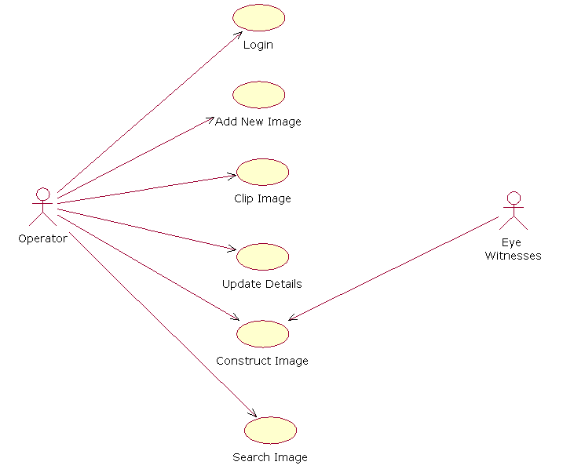

Fig 4.2 Use case diagram

**4.3 SEQUENCE DIAGRAM**

A sequence diagram is an interaction diagram that shows how object operate with one another and in what order. It is a construct of a message sequence chart .

A sequence diagram shows object interaction arranged in time sequence .It depicts the objects and classes involved in the scenario and the sequence of message exchanged between the objects.

A sequence diagram show as parallel vertical lines (lifelines),different processes or objects that live simultaneously, and, as horizontal arrows , the message exchanged between them, in the order which they occur .

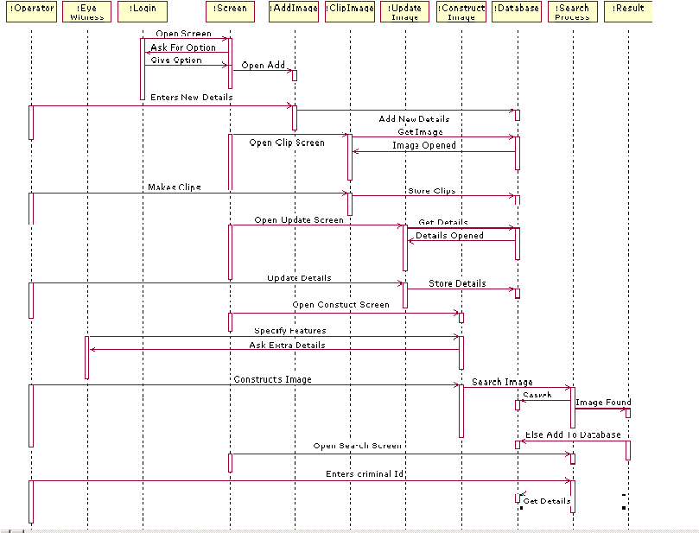

Fig 4.3 Sequence Diagram

**CHAPTER 5**

**TESTING &VALIDATION**

**5.1Unit Testing**

|  |  |  |  |  |
| --- | --- | --- | --- | --- |
| **S.no.** | **Screen** | **Input** | **Output** | **Remarks** |
| 1 | Login Page | User Id  Password | User validation | User will enter into Main Screen |
| 2 | Main Screen   * File * New | Criminal Details are entered | Details are stored in the database | New Menu is selected to enter new criminal details. |
| 3 | Main Screen   * File * Show Details | Display option is clicked. | Criminal Details are displayed | Display details menu is selected to get details from database. |
| 4 | Main Screen   * File * Exit | Exit Option is Clicked. | Screen will be exited | Screen will be shut down |
| 5 | Main Screen   * Edit * Clip Image | Criminal Image is clipped into different parts | The clips are stored in database | Clip image menu is selected to clip image and store them in database |
| 6 | Main Screen   * Edit * Update Details | Changes in the details of the criminals are entered | Details of the criminal are updated | Update details menu is selected to update the details of the criminals |
| 7 | Main Screen   * Identification * Construct Face | Different clips of criminals are selected and arranged in order | Face of the criminal is constructed | Construct face menu is to construct the criminal face from various clips stored in the database. |
| 8 | Main Screen   * Identification * Find Face | Show all suspects is checked | All suspects detail along with photo are displayed | Show more suspect menu is selected to get the details of all suspects and more possible suspect involved in crime. |
| 9 | Main Screen   * Help * About | About Face Identification is checked | The version and the overview of the system is displayed | About face identification system menu is selected to get the details of above system. |

**CHAPTER 6**

**EXPERIMENTAL RESULTS**

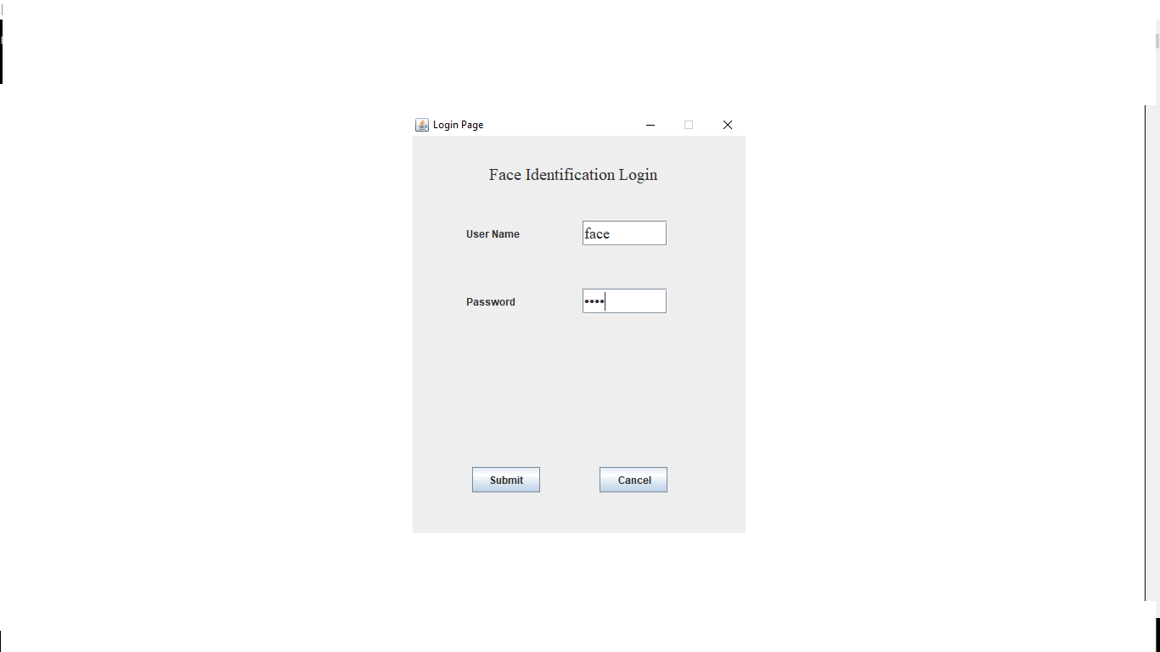

Fig 6.1 Login

To authenticate valid user the system is provided with user name and password.

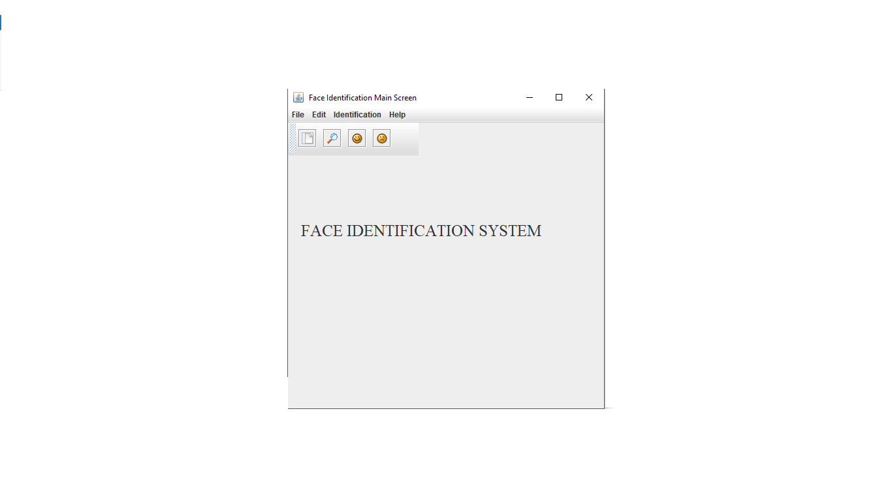

Fig 6.2 Main Frame

The main GUI after the system starts which provides various options .

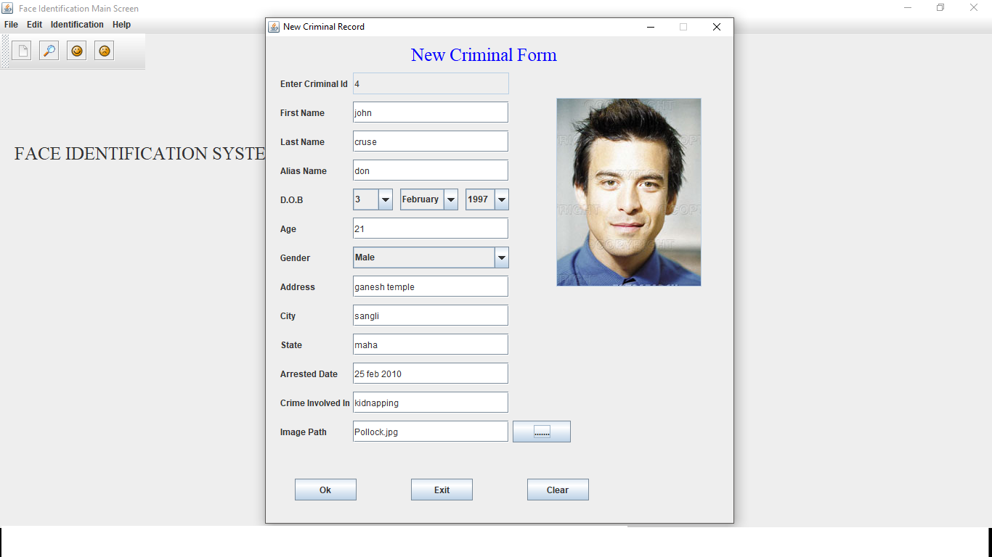

Fig 6.3 New Criminal Record

Insertion of new criminal records along with the details of the criminal like the name, age, city, crime committed.

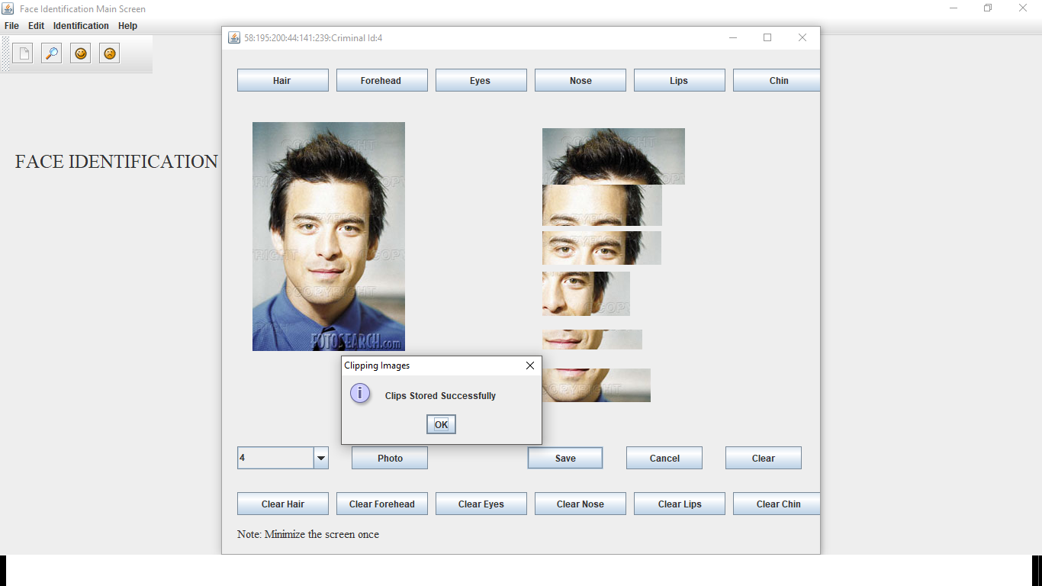

Fig 6.4 Image Clipping

It divides the images into different pieces such as hairs, forehead, eyes, nose and lips and store them in the database.

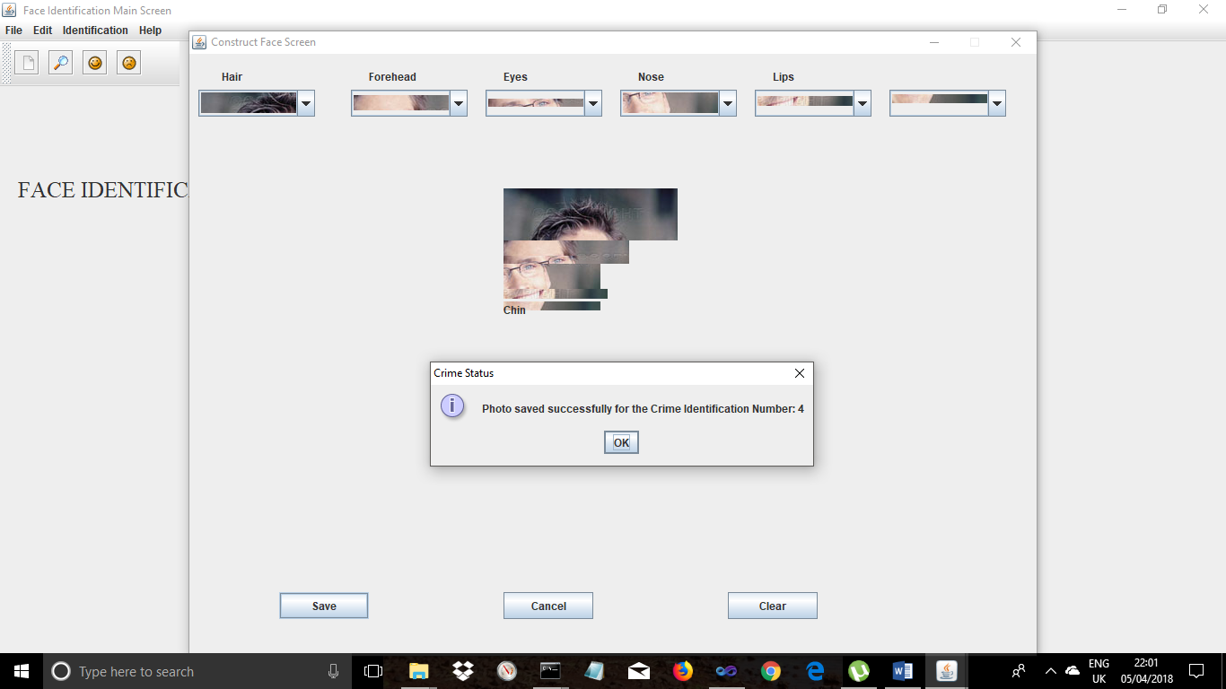

Fig 6.5 Clipped Images are constructed

Based on the eyewitnesses we are going to construct the images. The witness will give us instruction by looking onto the screen on which there will be the parts of the images like eyes, hairs etc.

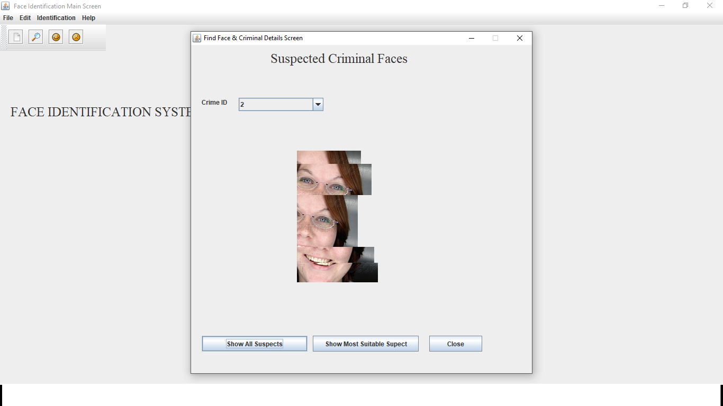

Fig 6.6 Clipped images to be compared

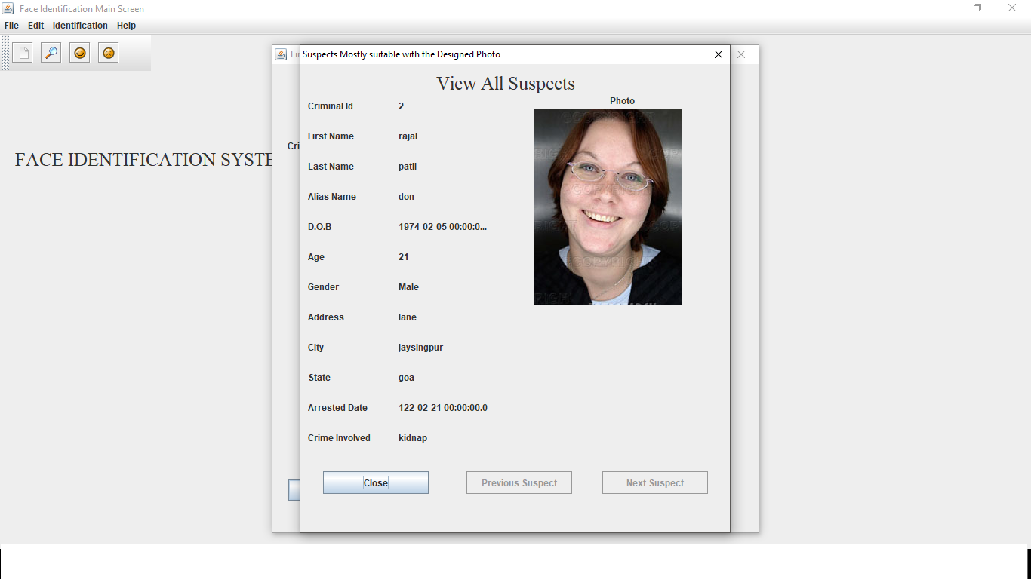

Fig 6.7 Possible suspect

If any image is matched then we identify him/her as the criminal else we add that new image again to the database.

**CHAPTER 7**

**CONCLUSION**

**7.1 Conclusion**

The purpose of face identification system is to identify criminals. In past years this process is carried out by humans. This process gives the exact image of the criminal but it is very difficult to identify the criminal details and also it requires much amount of human burden.

The main aim of our project is to overcome the drawbacks of human based system by using the machine based face identification process. In this process we store the details of criminal into the database along with his photo or image. Then we make the image into different clips containing hair, forehead, eyes, nose, lips and chin and store these clips into the database. When any crime occurs we compare the details given by the eyewitness with the clips already stored in the database and we will identify the criminal.

**7.2 FUTURE SCOPE**.

The future perspective of our project can be linking our face identification system with hardware like web cameras so that even a moving face can be captured and identified. Other than this the percentage of matching of image can also be found out .

**CHAPTER 8**

**REFERENCES**

1. ”The Complete Reference Java2” Tata McGraw-Hill publishing Company Limited. By Herbert Schildt.
2. “Software Engineering, A Practitioner’s Approach” Tata McGraw-Hill Publishing Company Limited. By Roger S. Pressman.
3. L.C Jain, ‘‘intelligent technique in face recognition.’’ Boca Raton: CRC Press, 1999.
4. Aurelio Campilho, MohamdKamel, “image analysis and recognition: international conference, ICIAR 2004.
5. Face Recognition: Cognitive and Computational Processes: Sam S. Rakover and Baruch Cahlon.